Journal of Academia Perspectives

RECEIVING INFORMATION ON THE INSTAGRAM APPLICATION WHEN STAY AT HOME AND WORK FROM HOME

Syatantra Rahutama,S.Kom., MMSI¹, Imam Himawan, S.Kom., M.Kom²
¹ Universitas Indraprasta PGRI
² Universitas Indraprasta PGRI

ARTICLE INFO |  | ABSTRACT
Article History: |  | The number of active Instagram application users every day reaches more than 500 million, and Instagram application users who upload nearly 500 million more stories every day. So that the flow of information that is shared by one user to another is very large, and when the CORVID 19 outbreak hit in various countries, users are treated to realtime information on the Instagram application. So when the government implies that people are only at home, Instagram application users can still receive information. Instagram application users can access information and also get entertainment from applications above 50%, measuring the attitude of receiving information from Instagram application users on smart phones using the Technology Acceptance Model (TAM) and by using ease, usability and attitude variables. The results of the analysis of the three variables are from the ease of making posts and also uploading photos so that stories and feeds have not been felt by some users, which is indicated by a value of 0.40 on the Ease of Attitude e1 → e13, namely external factors. But overall users take advantage of receiving information through the Instagram application.
Kata kunci:
Instagram;
Technology Acceptance Model;
Structure Equation Model;
Work From Home;
Masa Pandemi.
 |  | © 2020 The Author(s). Published by Universitas Indraprasta PGRI, Jakarta, Indonesia. This is an open access article under the CC BY license (https://creativecommons.org/licenses/by/4.0/)
Corresponding Author:
Syatantra Rahutama,S.Kom., MMSI, dan Imam Himawan, S.Kom., M.Kom,
Email: syatantra@unindra.ac.id

PRELIMINARY
Social media is currently growing rapidly and has a very large number of users and is supported by applications that make it easy for users, such as Facebook, Twitter, Path, Instagram, and others. Social media is a form of human communication (Hamzah, 2011) that continues to develop through technology, or a communication revolution in structural and technical forms (Siti Ezaleila Mustafa & Azizah Hamzah, 2011).
One of the social media that is currently being loved by smartphone users is the Instagram application, Instagram application users in 2018 have reached 1 billion (Statista and TNW, 2019). With the presence of the Instagram application, smartphone users get access to information and entertainment when the Corona virus spreads or what is known as CORVID 19.
Launching stay at home or abbreviated (SAH) and Work From Home or abbreviated as WFH by the government of the Republic of Indonesia, the Instagram application is one of the social media that can function as entertainment and access to information from news and media. government accounts, both central and local governments. .
With so many Instagram users doing SAH and WFH, the increase in the level of access to Instagram has increased, therefore there is user interest in the Instagram application. This interest becomes a benchmark for feedback for reviewers of the Instagram application. Therefore this study measures the attitude of Instagram users who receive information from various accounts which is influenced by the usability and ease of access to information and entertainment.
The features provided by the Instagram application are numerous, such as Stories, and Feeds and IGTV which can be entertainment. But not all Instagram application users get the convenience and advantages of IGTV features. Therefore, to measure the attitude of Instagram application users on smart phones can be influenced by its ease and use, this study uses the Technology Acceptance Model or abbreviated as TAM (Davis, 1989). The variables used as a model in this study are Attitude, Ease, and Benefit. Of the three variables will be analyzed using the Structural Equation Model (SEM).

METHOD
The method used in this study is the TAM model introduced by Davis and the use of the TAM model can measure the attitudes of Instagram application users by using 3 variables, namely as follows:

H₁
Mudah
Sikap
H₀
H₂
Manfaat

Gambar 1. Model Penelitian

.
From testing these 3 (three) variables, the following hypothesis is taken:

H0: Benefits of the Instagram application feature can affect the Ease of access to information from other accounts and also get entertainment on the IGTV feature when the SAH and WFH movements are launched

H1: Ease of use features including IGTV features and access to information Affect the attitude of Instagram application users when the SAH and WFH movements are launched.

H2: The use of features in the Instagram application and entering the IGTV feature and the availability of information can affect the attitude of Instagram application users when SAH and WFH are announced

Each variable has an indicator as an exogenous variable that will play a role in providing data for analysis in SEM. These indicators are the questions on the questionnaire filled out by the respondents, with the indicators as follows:
Mudah:
MDH1, MDH2, MDH3, MDH4, MDH5, MDH6, MDH7

Manfaat:
MFT1, MFT2, MFT3, MFT4

Sikap:
SKP1, SKP2, SKP3, SKP4

This indicator was developed into a questionnaire distributed through Google Form with 102 respondents. The link from Google Form is spread via instant whatsapp message. Then after the respondent fills in the google form, then the validity and reliability tests are carried out for the validity of these indicators, and there are several indicators that do not have significant value, so these indicators must be discarded. Then the valid variables and indicators are then entered into a model chart using AMOS software to be analyzed by the SEM method.
The initial models that are put on the model chart to AMOS are as follows:
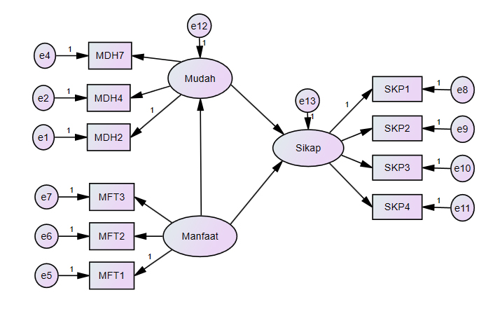

Figure 2. Early model in SEM

RESULTS AND DISCUSSION
The initial model included in AMOS was then analyzed by following several modifications according to the largest Modification Indices (MI) value, after the MI value was no longer there. Then get a fit model like the following image:

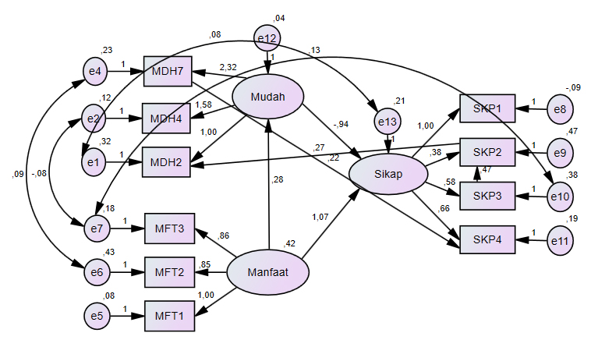

Gambar 3. Fit Model

SEM results are shown in the following table:

Tabel 1. Regression Weights: (Group number 1 - Default model)
 |  |  | Estimate | S.E. | C.R. | P | Label
Mudah | <--- | Manfaat | ,278 | ,082 | 3,409 | *** | par_8
Sikap | <--- | Mudah | -,938 | ,456 | -2,057 | ,040 | par_9
Sikap | <--- | Manfaat | 1,073 | ,144 | 7,470 | *** | par_10
SKP3 | <--- | Sikap | ,577 | ,080 | 7,254 | *** | par_6
MDH7 | <--- | Mudah | 2,325 | ,612 | 3,796 | *** | par_2
SKP2 | <--- | Sikap | ,380 | ,104 | 3,637 | *** | par_5
SKP2 | <--- | SKP3 | ,467 | ,110 | 4,261 | *** | par_14
MDH2 | <--- | Mudah | 1,000
MDH4 | <--- | Mudah | 1,579 | ,459 | 3,440 | *** | par_1
MFT1 | <--- | Manfaat | 1,000
MFT2 | <--- | Manfaat | ,849 | ,112 | 7,608 | *** | par_3
MFT3 | <--- | Manfaat | ,861 | ,080 | 10,770 | *** | par_4
SKP1 | <--- | Sikap | 1,000
SKP4 | <--- | Sikap | ,664 | ,067 | 9,980 | *** | par_7
SKP4 | <--- | MDH7 | ,221 | ,051 | 4,304 | *** | par_12
MDH2 | <--- | SKP2 | ,265 | ,070 | 3,771 | *** | par_16

Easy variable → Attitude has a value of 0.04 which exceeds 0.001, so it is not significant (Siswoyo, 2013) or it can be interpreted that there are indicators on the Easy variable that do not match the existing model. This can be seen in the covariance variables in the following table:

Tabel 2. Covariances: (Group number 1 - Default model)
 |  |  | Estimate | S.E. | C.R. | P | Label
e1 | <--> | e13 | ,077 | ,026 | 2,987 | ,003 | par_11
e7 | <--> | e10 | ,128 | ,028 | 4,519 | *** | par_13
e2 | <--> | e7 | -,076 | ,019 | -4,025 | *** | par_15
e6 | <--> | e4 | ,089 | ,040 | 2,254 | ,024 | par_17

There is a covariance of e1 ↔ e13 which has a value of 0.003 and it can be seen in Figure 3 that the covariance of e1 is included in the MDH2 indicator, namely the ease of making posts on the Instagram application, this is influenced by external factors, namely not measurable on this indicator, as well as the covariance e6 ↔ e4, the MDH7 indicator with the MFT2 indicator is not aligned, which is about uploading photos and videos with users being able to interact with friends, which is influenced by SAH and the WFH factor where users don't upload many photos and videos, so friends in the Instagram application contact cannot interact via posts or direct messages.

Variable Benefits → Easy with Benefits → Sika [has reached a significant value, so that H0, namely the superiority of the Instagram application features, affects the ease of access to information and also Instagram users can enjoy entertainment on the Instagram application during SAH and WFH. Then H2, namely the use of features in the Instagram application, affects the user's attitude to interact a lot with the Instagram application in receiving information and also getting entertainment during SAH and WFH. However, H1, namely the ease of using Instagram application features, has not been fully felt by Instagram application users when SAH and WFH are caused by external factors.

CONCLUSION

Based on the results of the SEM analysis, it was found that Instagram application users benefit from features such as posting comments and making posts on Stories and Feeds and including IGTV which can be entertainment while staying at home and also working from home. Then the advantages of the Instagram application feature make it easier for users to access account information in the Instagram application. However, Instagram users have not fully experienced the ease of using existing features due to external factors

SUGGESTION
It is hoped that research on Instagram in the use of the TAM model can then include all the variables that exist in TAM, to then be developed into TAM 2.

REFERENCE
Chuttur, M., 2009. Overview of the Technology Acceptance Model: Origins,Developments and Future Directions. Working Papers on Information Systems, p. 16.
Hamzah, S. E. M. &. a., 2011. Media Baharu yang Baharu: Trend Penggunaan Jaringan SoSial dalaM Kalangan Pengguna di MalaySia. Jurnal PengaJian Media, 13(Malaysian Journal of Media studies ), pp. 93-110.
Ortiz-Ospina, E., 2019. The rise of social media. [Online]
Available at: https://ourworldindata.org/rise-of-social-media
Siswoyo, P. D., 2013. Structural Equation Model untuk Penelitian Manajemen. Jakart: PT.IPU.
.

